I&D Learning Dashboard Reporting 2.0

Solution Requirements Specifications

Version: 2.0

**Published**: 02/02/2024

**Project SharePoint Link**: [General](https://capgemini.sharepoint.com/:f:/r/sites/GlobalLearningDashboard/Shared%20Documents/General?csf=1&web=1&e=jobVV2)

## REVISION HISTORY

[Required. List changes between each release. Increment Release Number by 1 only between published versions.]

| **Version #** | **Date** | **Revised By** | **Description of Changes** |
| --- | --- | --- | --- |
| 1.0 | 15/12/2023 |  | First Version |
| 2.0 | 02/02/2024 |  | Second Version |
|  |  |  |  |
|  |  |  |  |
|  |  |  |  |
|  |  |  |  |
|  |  |  |  |
|  |  |  |  |
|  |  |  |  |
|  |  |  |  |
|  |  |  |  |

SUPPORTING DOCUMENTS

|  |  |
| --- | --- |
| **Document Number** | **URL** |
| **1** | [Calculations.txt](https://capgemini.sharepoint.com/:t:/r/sites/GlobalLearningDashboard/Shared%20Documents/General/Project%20Requirement%20Docs/Calculations.txt?csf=1&web=1&e=NDLIfg) |
| **2** | [I&D India Learning KPI Status (2)- Oct 2023.pptx](https://capgemini.sharepoint.com/:p:/r/sites/GlobalLearningDashboard/Shared%20Documents/General/Kickstart%20Docs/I%26D%20India%20Learning%20KPI%20Status%20(2)-%20Oct%202023.pptx?d=w065ba207377d4d47b81687a7a6bb6a93&csf=1&web=1&e=gMzMFQ) |
| **3** | [I&D Learning Dashboard Phase 1.0](https://app.powerbi.com/links/y8AbSRSGn5?ctid=76a2ae5a-9f00-4f6b-95ed-5d33d77c4d61&pbi_source=linkShare) |

TABLE OF CONTENTS

REVISION HISTORY 2

SUPPORTING DOCUMENTS 2

3 Solution Requirements Specifications 3

3.1 Introduction 3

3.1.1 Overview 3

3.1.2 Purpose 3

3.1.3 Intended Audience 3

3.1.4 Scope and Objectives 4

3.1.4.1 Objective 4

3.1.4.2 In Scope 4

3.1.4.3 Out of Scope 4

3.1.5 Definitions, Acronyms, and Abbreviations 4

3.1.6 Stakeholders 4

3.2 High-Level Functional Flow 4

3.2.1 High-Level Functional Flow 4

3.2.2 Functional Area Impacts 4

3.3 Assumptions / Risks / Dependencies / Constraints / Application Rules 4

3.3.1 Assumptions 4

3.3.2 Risk Analysis 4

3.3.3 Dependencies and Constraints 5

3.3.4 Application Rules 5

3.4 Functional Requirements 5

3.4.1 Functional Requirements 5

3.4.2 Error Codes 5

3.5 Appendix 6

# Solution Requirements Specifications

## Introduction

This dashboard offers the ability to customize reports and data models, delivering meaningful insights tailored for decision-makers within an organization.

### Overview

To build I&D Learning Power BI Dashboard w.r.t Global region-wise, portfolio-wise, and country-wise KPIs.

### Purpose

To monitor and track monthly, quarterly, and yearly learning data for employees globally.

### Intended Audience

Business POCs: I&D Leads

* Owner: Shaik Sajjad Ahmed, Bhattacharya Subarna
* SME(Subject Matter Expert): R Bhuvana, Balecha Shakti, Inamdar Mehrunnisa

And Power BI Development Team:

* Project Manager: Jeevan Akula
* Development Lead: Bandam Kamal Praneeth
* Team Lead: Sushma Tumati
* Developers:Thota Divya sree, Thanmayi Kambhampati, Chaya Uppalapati, Mounika Ramoji

### Scope and Objectives

Simple user-friendly dashboard to view region and country wise snaps.

#### Objective

The task involves constructing a dashboard that categorizes Portfolio Key Performance Indicators (KPIs) and Actual/Targets Cards based on regions and countries.

#### In Scope

Team of Power BI trained developers to built business user dasdboards.

#### Out of Scope

* Good understanding of how KPIs are calculated.
* Need Source files on time to validate the data.

### Definitions, Acronyms, and Abbreviations

| **Term** | **Definition** |
| --- | --- |
| I&D | Insights and Data |
| FS | Financial Servies |

### Stakeholders

* Owner: Shaik Sajjad Ahmed
* SME: R Bhuvana, Balecha Shakti

## High Level Functional Flow

### High Level Functional Flow

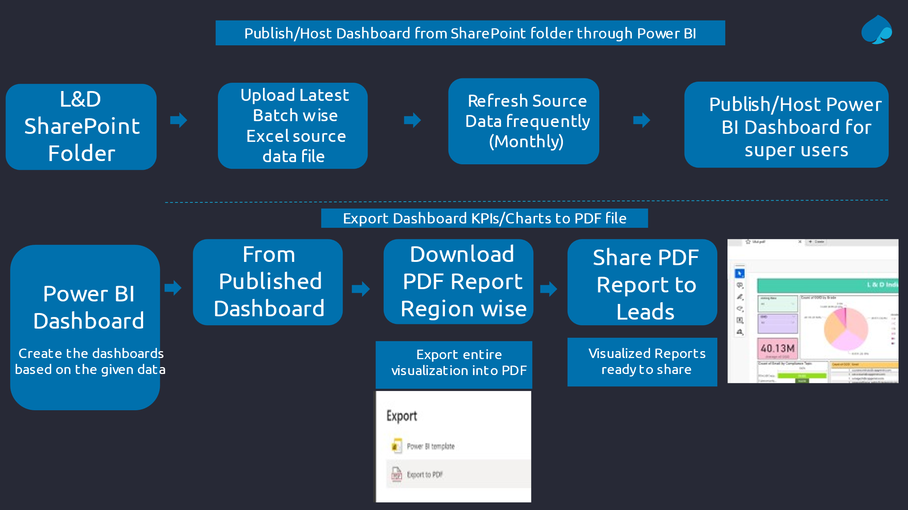

### Functional Area Impacts

N/A

## Assumptions / Risks / Dependencies / Constraints / Application Rules

### Assumptions

| **Assumption ID** | **Assumption Description** | **Accountable** |
| --- | --- | --- |
|  |  |  |
|  |  |  |
| ­ |  |  |

### Risk Analysis

| **Risk ID** | **Risk Description** | **Likelihood**  **(H, M, L)** | **Impact**  **(H, M, L)** | **Mitigation** |
| --- | --- | --- | --- | --- |
|  |  |  |  |  |
|  |  |  |  |  |
|  |  |  |  |  |
|  |  |  |  |  |

High (H), Medium (M), Low (L)

### Dependencies and Constraints

| **Dependency or Constraint ID** | **Dependency or Constraint Description** | **Severity**  **(H, M, L)** | **Accountable** |
| --- | --- | --- | --- |
| 1 | Data Missing In **Industry Category**, **Pass Status** and **Score.** | H |  |
| 2 | In Mandatory Training, Sustainability Campus, and Technology portfolio Cloud Campus they **mention Date** but have to know whether it is the **Start Date, End Date, or Completion Date**. | H |  |
| 3 | Activity Code is not in an understandable way. | M |  |
| 4 | In Cloud Campus **Content Provider, Complete % and Not Complete%** Data is missing**.** | H |  |
| 5 | Need clarity on LH. | H |  |

High (H), Medium (M), Low (L)

### Application Rules

## Functional Requirements

### Functional Requirements

| **FRQ #** | **Requirement Description** | **Comments** |
| --- | --- | --- |
| 1 | Home Page Creation | Generate buttons corresponding to different regions. |
| 2 | Buttons on the Home page | With just one click, access comprehensive details instantly. |
| 3 | Establishing navigation across multiple regions | Formating the Dashboard according to Capgemini standards. |
| 4 | Create a slicer/filter of Country, Portfolio, Status, Year and Grade | Phase 1 Dashboard Connection[(View more details)](https://capgemini.sharepoint.com/:u:/r/sites/GlobalLearningDashboard/Shared%20Documents/General/I%26D%20Dashboard%20Demo%202.pbix?csf=1&web=1&e=MNSsWO) |
|  |  |  |

### Error Codes

|  |  |  |
| --- | --- | --- |
| **Error ID** | **Error Description** | **Display or Logging Message Text** |
|  |  |  |
|  |  |  |
|  |  |  |

## Appendix